**Introduction to JQuery**

**13th February 2019**

**\* Console "Hello Word" in document.ready function.**

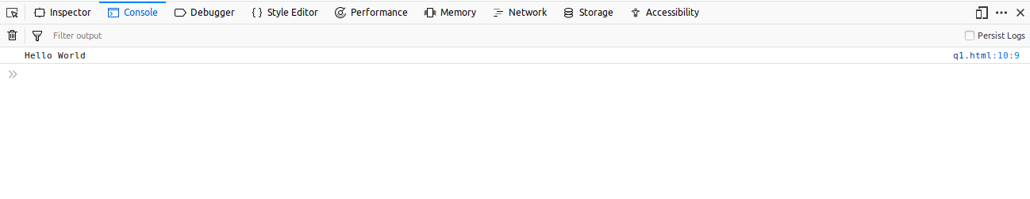

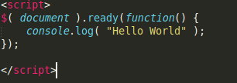

Here we have used document.ready function in which we have used console.log to console Hello World.

**\* Select a ID name "#test" and add class "load" when DOM is loaded**.

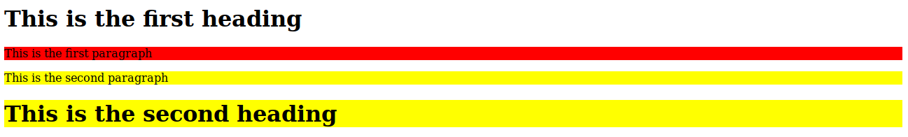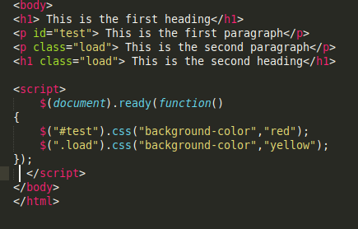

Here we have given id name “#test” and class name “.load” to the elements and then the elements with id were given css of red background color and the elements with class were given css of yellow background.

**\* Change the color of element which class name end with "-new".**

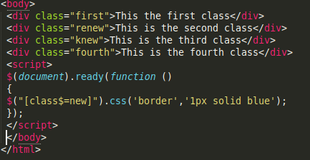

Here we have given class name to all the elements and for selecting the classes whose name ends with new we have used **$(“[class$=new]”)** so that the elements can be separated and have been given css in which border has been given to all those elements.

**\* Disable submit button using jquery attr method.**

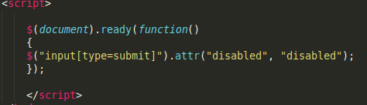

In this case we have made a label a text area and a button where on clicking the button the text should have been submitted but here with the help of attr method we disabled the button hence no text could be submitted.

**\* Change the font size of ".target" which has parent element with id name "#main"**

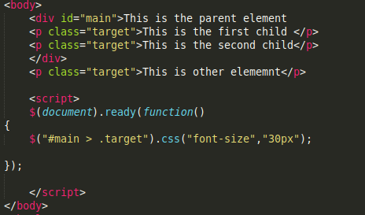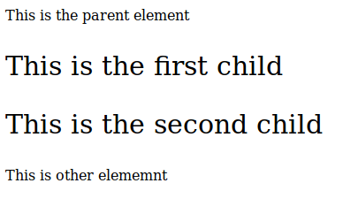

Here we created a id main which has the parent element and the child element with class target and in the document.ready function we changed the css off all the child elements using **$(“#main > .target”).**

**\* After page load change the HTML of div element with "p" element.**

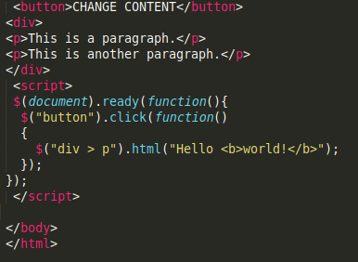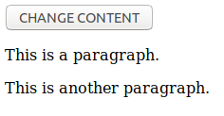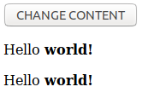

Here we used the button to change the content of p elements under the div elements. Now on calling the function we can change the content.

**\* Bind a click function to an "click" element and append next "click" next to it.**

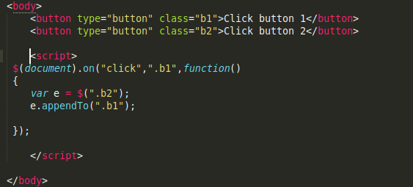

Here we made two buttons and gave them class as b1 and b2. Now in the function we used appendTo so that we can append the next click.

**\* Click event not working on element which added dynamically or via script, make it work using .on method.**

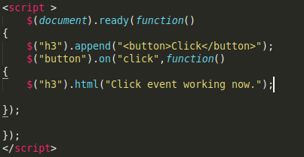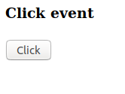

Here we appended h3 with button where the button on click works and gives the output as click event working now.

**\* Get dropdown selected value on onchanage event and append in div container.**

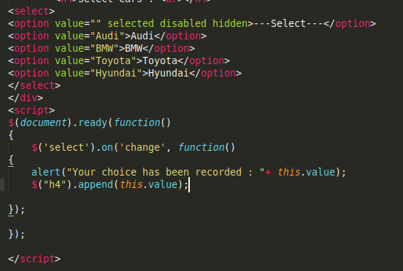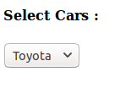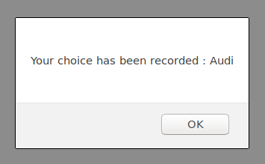

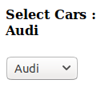

First we created the dropdown under the div tag and then using the document.ready function in which when we select the car the choice gets recorded and then after we use append the choice is shown which was recorded.

**\* Create a dropdown menu using hover method in jquery.**

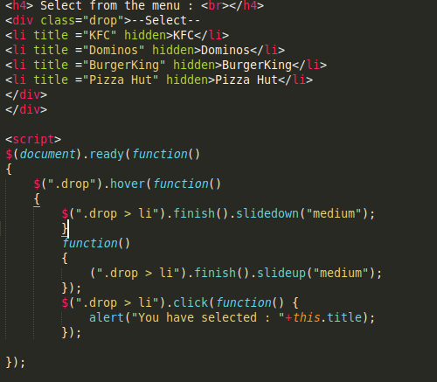

Here we have created a dropdown list which on bringing hover opens the list were we have slide down and slide up and on clicking it we get the outcome what we have selected.

**\* On clicking on "**[**google**](https://www.google.com)**" tag. It is taking us to google homepage. Stop it from happening.**

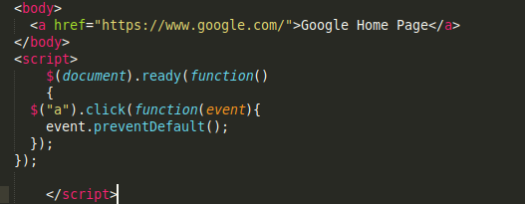

First we created a <a> in which we gave the link of google homepage so that on clicking the link the homepage opens but here by using preventDefault() we prevented that link from opening the homepage.

**\* Get the max height of elements using jquery each method.**

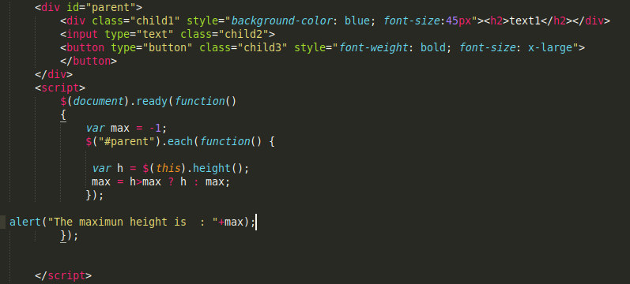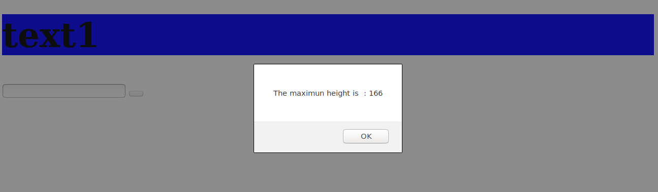

**\* Change color of every cell which has number larger than 1.**

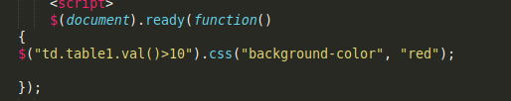

Here we have specified every value of the table row and whose number is greater than 10 will get red color.